Home Learning – English
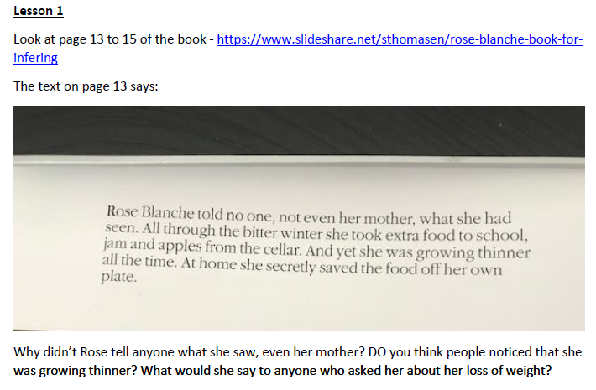
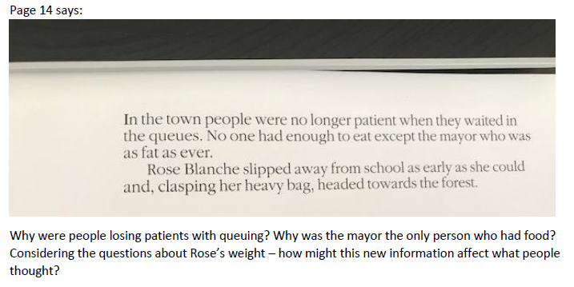
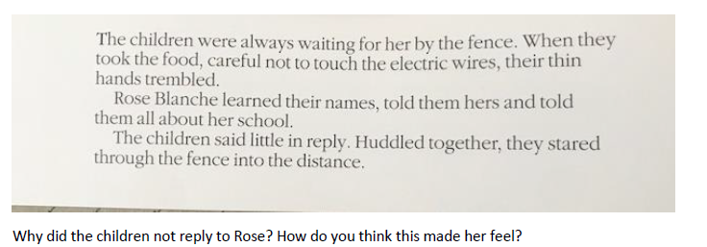

Lesson 2
Work through the attached PowerPoint
Lesson 3
Write a description of what Rose Blanche could see, hear, smell and feel when she saw the children in the concentration camp. Remember to use the different sentence types you practiced yesterday.
Lesson 4
